**Introduction**

The Cyclistic Bike Share Case Study is a capstone project for the Google Data Analytics Professional Certificate on Coursera. In this project, I will follow the data analysis process which I learned from the course: Ask, Prepare, Process, Analyze, Share and Act to analyze the data.

**Background**

In 2016, Cyclistic launched a successful bike-share offering. Through the years, the program has expanded significantly to a fleet of 5,824 bicycles that are geotracked and locked into a network of 692 stations across Chicago. The bikes can be unlocked from one station and returned to any other station within the network at their convenience.

Cyclistic’s marketing strategy so far relied on building general awareness and appealing to broad consumer segments. The company offers flexible pricing plans that cater to diverse needs of users including single-ride passes, full-day passes and annual memberships. Cyclistic sets itself apart by also offering reclining bikes, hand tricycles, and cargo bikes, making bike-share more inclusive to people with disabilities and riders who can’t use a standard two-wheeled bike. The majority of riders opt for traditional bikes; about 8% of riders use the assistive options. Cyclistic users are more likely to ride for leisure, but about 30% use the bikes to commute to work each day.

The director of marketing believes the company’s future success depends on maximizing the number of annual memberships. Therefore, as a data analyst my team wants to understand how casual riders and annual members use Cyclistic bikes differently. From these insights, team will design a new marketing strategy to convert casual riders into annual members.

**Approach/Steps**

1. **Ask**

**Business Task -** design marketing strategies to convert casual riders to members by understanding how annual and casual riders differ. Maximizing the number of annual members will be key to future growth of the company

* **Key tasks**
* Identify the business task
* *convert casual riders into members*
* Consider key stakeholders
* *Director of marketing*
* *Cyclistic Manager*
* *Cyclistic marketing analytics team*
* *Cyclistic executive team*

1. **Prepare**

* **Data Source**
* [Divvy_Trips_2019_Q1](https://docs.google.com/spreadsheets/d/1uCTsHlZLm4L7-ueaSLwDg0ut3BP_V4mKDo2IMpaXrk4/template/preview?resourcekey=0-dQAUjAu2UUCsLEQQt20PDA#gid=1797029090)
* [Divvy_Trips_2020_Q1](https://docs.google.com/spreadsheets/d/179QVLO_yu5BJEKFVZShsKag74ZaUYIF6FevLYzs3hRc/template/preview#gid=640449855)
* [Divvy_Trips_2025](https://divvy-tripdata.s3.amazonaws.com/202502-divvy-tripdata.zip)

[Note:*the data has been made available by Motivate International Inc. under* [*license*](https://www.divvybikes.com/data-license-agreement)*]*

* **Tools**
* Data cleaning & processing - SQL on Big Query and Google sheets
* Data visualization - Tableau

1. **Process**

The basis for this analysis is Feb/March 2025 data and the steps for processing the data are as follows:

1. **Data Combining**

| **SELECT * FROM `inlaid-marker-454718-q1.CyclisticData.Cyclistic_2025` AS march**  **FULL JOIN `inlaid-marker-454718-q1.CyclisticData.cyclisticDataMarch` AS feb**  **ON march.ride_id = feb.ride_id** |
| --- |

The 2 tables for the month of February and March were JOIN together into a single table. The table consists of 450035 rows.

1. **Data Exploration**

I ran the queries for each column to understand any errors, missing value , inconsistencies and determine the data type.

| **No.** | **Variable** | **Description** |
| --- | --- | --- |
| 1 | ride_id | Unique ID assigned to each ride |
| 2 | rideable_type | Classic, docked or electric |
| 3 | started_at | Date and time at the start of trip |
| 4 | ended_at | Date and time at the end of trip |
| 5 | start_station_name | Name of the station where the bike ride journey started from |
| 6 | start_station_id | ID of the station where the bike ride journey started from |
| 7 | end_station_name | Name of the station where the bike ride journey ended at |
| 8 | end_station_id | ID of the station where the bike ride journey ended at |
| 9 | start_lat | Latitude of starting station |
| 10 | start_lng | Longitude of starting station |
| 11 | end_lat | Latitude of ending station |
| 12 | end_lng | Longitude of ending station |
| 13 | member_casual | Type of membership of each rider |

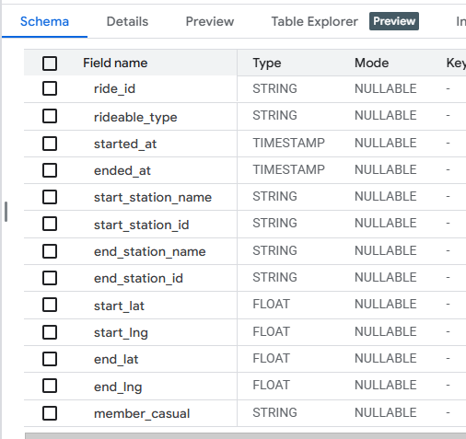

1. **Data Cleaning**

The data has been cleaned before analysis, by following steps

* Removed duplicates and trips with null values
* Adding 3 columns: ‘ride_length_in_mins’,’day_of_week’ and ‘month’
* Sort and filter the data

| **SELECT**  **april.member_casual,**  **april.start_station_name,**  **COUNT (april.ride_id) AS no_of_rider**  **FROM inlaid-marker-454718-q1.CyclisticData.Cyclistic_2025 AS april**  **GROUP BY**  **april.member_casual, april.start_station_name**  **ORDER BY**  **no_of_rider ASC** |
| --- |

A summary of your analysis

* *Casual member in April ’25 = 85869*
* *Member in April ’25 = 212286*
* *Casual member in March ’25 = 27754*
* *Member in March ’25 = 124126*
* *There are more than 300 stations with a singer rider as casual or member of Cyclist*

1. **Analyze**

**Data Analysis**

The cleaned data was imported in Tableau for analysis and the finding are summary as

Below –

1. **Cyclistic Member and Casual Bikers total for the month of Feb/March 2025**

* Count of Casual bikers : 8,984
* Count of Member bikers : 33,002



1. **Type of Bikes**

* There are two types of bicycles: *Classic, electric*
* Electric bikes are more popular among members and casual riders over Classic bikes

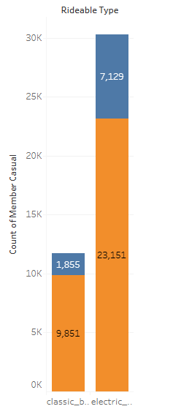

1. **Trips taken in a Week**

* Cyclistic members have the greatest activity on Wednesday and lowest movements on Mondays
* Casual riders have highest activity on Saturdays and lowest activity on Thursdays

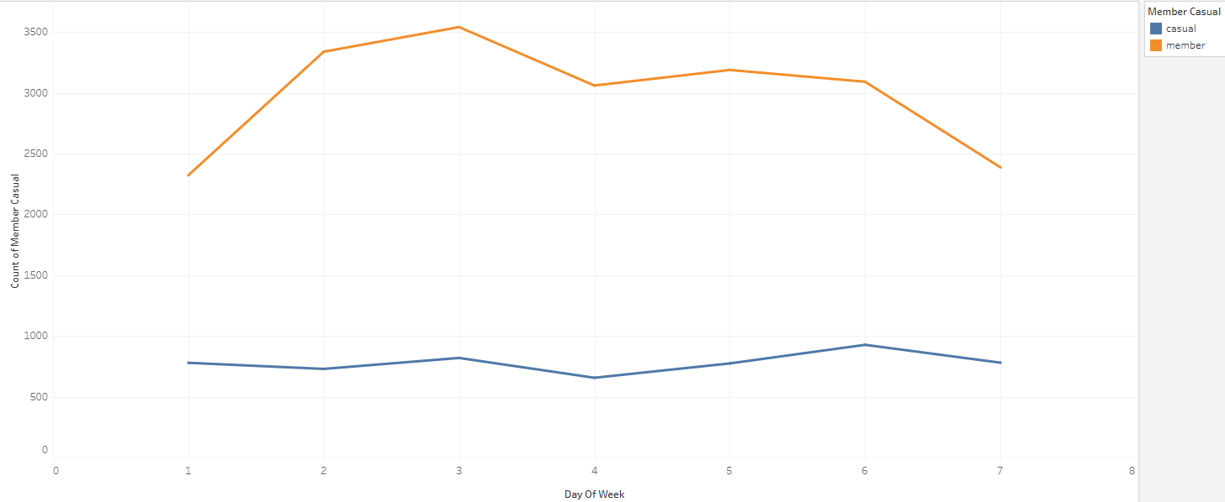

1. **Cyclistic Member/Casual Count on Start Stations**

* MAX member biker count is on Ravenswood station : 451
* MAX casual biker count is on Sheridan Road station : 124

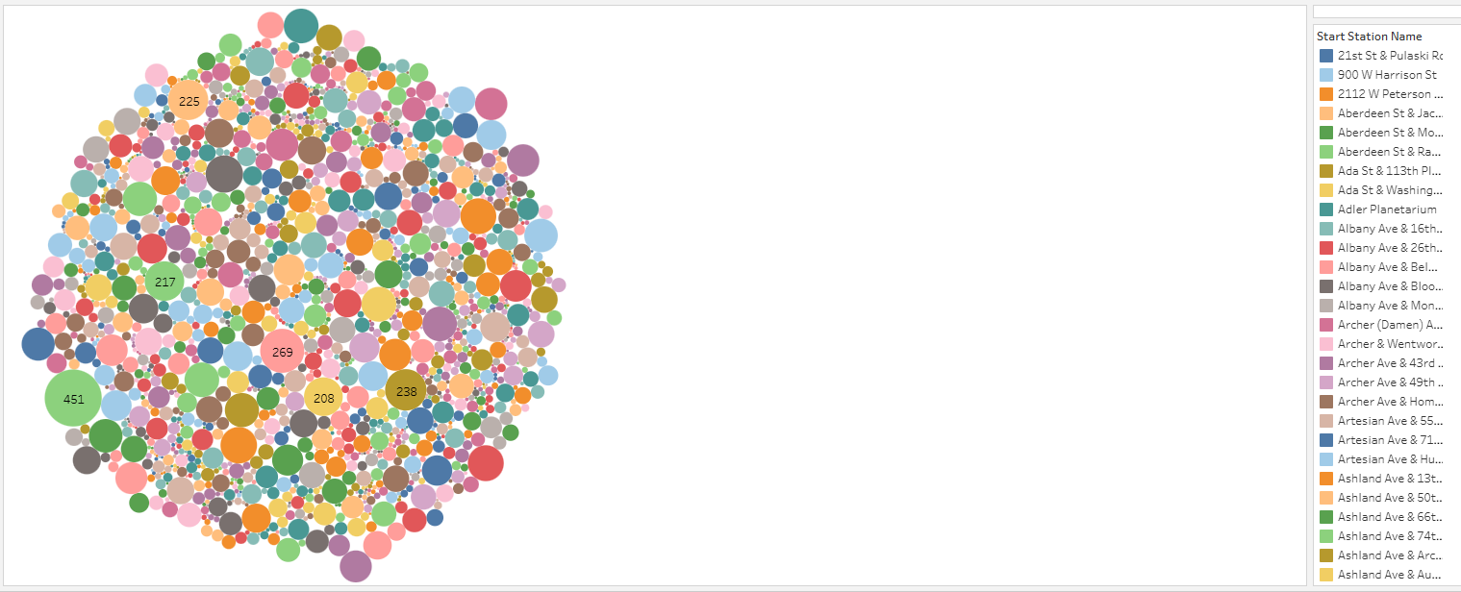

1. **Average Ride Duration in Minute**

* Average bicycle ride for members is about 25 minutes whereas casual bike riders have an average ride length of 15 minutes. Hence, the ride duration of Cyclist members are approximately two times smaller than casual riders.

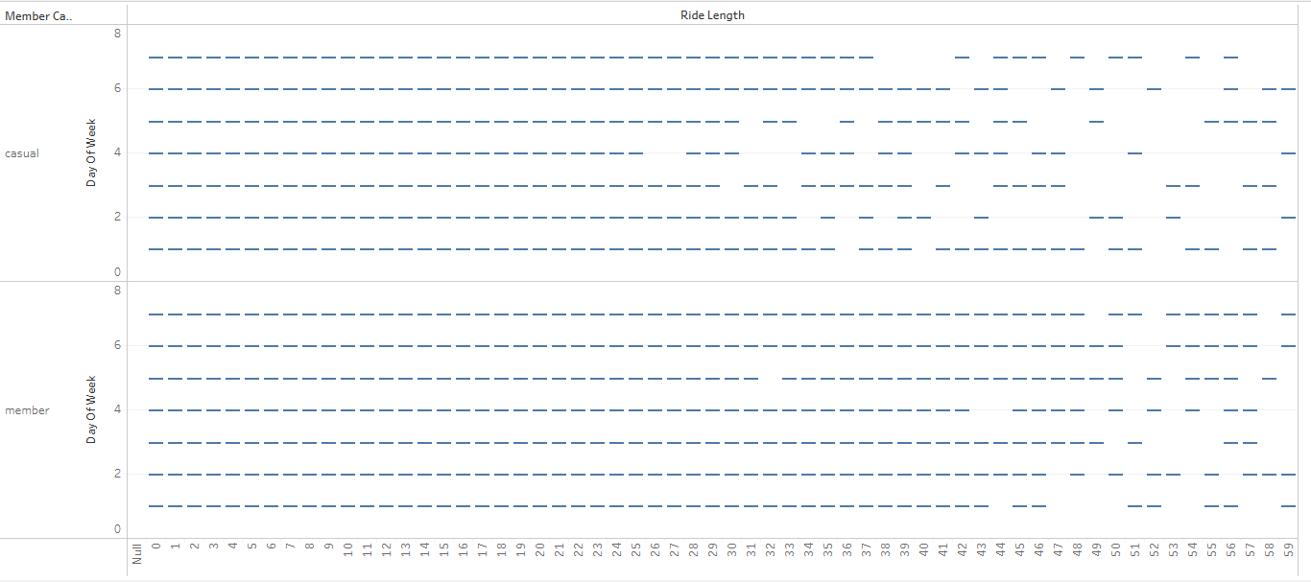

1. **Share**

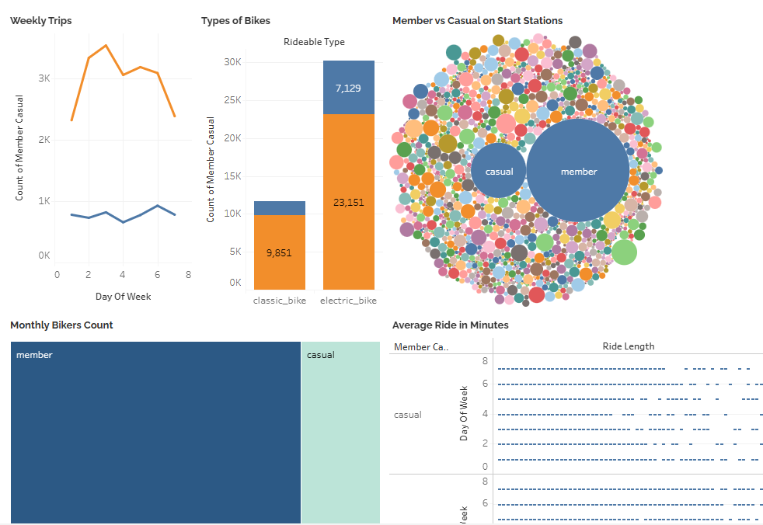

**Similarities:**

* Both Cyclistic members and casual riders prefer electric bicycles over classic bicycles
* Both Cyclistic members and casual riders have higher average ride duration on the weekends as compared to on weekdays

**Differences:**

* Cyclistic members go on more rides than casual riders.
* Cyclistic members have a larger average ride length (25 minutes) than casual riders (15 minutes). are more active on weekdays
* Cyclistic members are having consistent rides throughout the week which is on peek on weekend while casual rides are more active during the weekdays

1. **Act**

**Recommendations**

Based on the above analysis, the marketing strategies to convert casual riders to Cyclistic members can leverage following approach:

* **Seasonal campaigns**

Introduce seasonal campaigns by offering special weekdays offers, limited time discounts appeal to casual riders.

* **Group Membership Discounts**

Offer discounted plans for friends, students and families can encourage

collective membership.

* **Membership Loyalty Points System**

Implement a membership loyalty points system for users to collect points for each ride and rewards such as membership discount.

* **Social Media Engagement**

Leveragedigital media, including media platforms to engage with both casual riders and members by creating content to promote the joy of bike riding.